**DAX Queries**

1. **To create a new date table-**

* Inserting new column as “Date”

Date = CALENDAR(MIN(ecommerce_data[order_date]), MAX(ecommerce_data[order_date]))

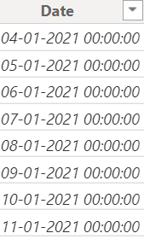

* To extract year from the date column-

Year = YEAR('Date'[Date])

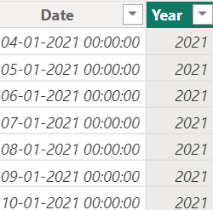

* To extract month from the date column-

Month = FORMAT('Date'[Date], "mmmm")

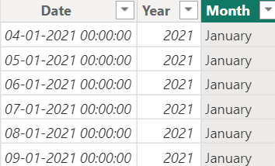

* To give month no.-

Month No. = MONTH('Date'[Date])

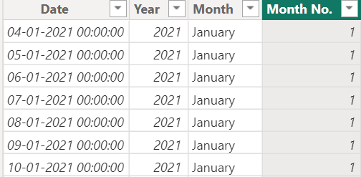

1. **To create new measures for KPIs-**

* Year to Date (YTD) Sales-

YTD Sales = TOTALYTD(SUM(ecommerce_data[sales_per_order]), 'Date'[Date])



* Previous Year to Date (YTD) Sales-

PYTD Sales = CALCULATE(SUM(ecommerce_data[sales_per_order]), DATESYTD(SAMEPERIODLASTYEAR('Date'[Date])))



* Year on Year (YoY) Sales-

YoY Sales = ([YTD Sales] - [PYTD Sales]) / [PYTD Sales]

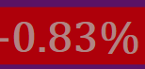

* Sales Icon-

Sales Icon = var positive_icon = UNICHAR(9650)

            var negetive_icon = UNICHAR(9660)

           var result = IF([YoY Sales]>0, positive_icon, negetive_icon)

return result



* Sales Background color-

Sales Background Color = IF([YoY Sales]>0, "Green", "Red")



* Year to Date (YTD) Profit-

YTD Profit = TOTALYTD(SUM(ecommerce_data[profit_per_order]), 'Date'[Date])



* Previous Year to Date (YTD) Profit-

PYTD Profit = CALCULATE(SUM(ecommerce_data[profit_per_order]), DATESYTD(SAMEPERIODLASTYEAR('Date'[Date])))



* Year on Year (YoY) Profit-

YOY Profit = ([YTD Profit] - [PYTD Profit]) / [PYTD Profit]



* Profit Icon-

Profit Icon = var positive_icon = UNICHAR(9650)

            var negetive_icon = UNICHAR(9660)

              var result = IF([YOY Profit]>0, positive_icon, negetive_icon)

              return result



* Profit Background color-

Profit Background Color = IF([YOY Profit]>0, "Green", "Red")



* Year to Date (YTD) Quantity-

YTD Quantity = TOTALYTD(SUM(ecommerce_data[order_quantity]), 'Date'[Date])



* Previous Year to Date (YTD) Quantity-

PYTD Quantity = CALCULATE(SUM(ecommerce_data[order_quantity]), DATESYTD(SAMEPERIODLASTYEAR('Date'[Date])))



* Year on Year (YoY) Quantity-

YoY Quantity = ([YTD Quantity] - [PYTD Quantity]) / [PYTD Quantity]



* Quantity Icon-

Quantity Icon = var positive_icon = UNICHAR(9650)

                var negetive_icon = UNICHAR(9660)

              var result = IF([YoY Quantity]>0, positive_icon, negetive_icon)

              return result



* Quantity Background color-

Quantity Background Color = IF([YoY Quantity]>0, "Green", "Red")



* Profit margin-

Profit Margin= SUM(ecommerce_data[profit_per_order]) / SUM(ecommerce_data[sales_per_order])



* Year to Date (YTD) Profit Margin-

YTD Profit Margin = TOTALYTD([Profit Margin], 'Date'[Date])



* Previous Year to Date (YTD) Profit Margin –

PYTD Profit margin = CALCULATE([Profit Margin], DATESYTD(SAMEPERIODLASTYEAR('Date'[Date])))



* Year on Year (YoY) Profit Margin-

YoY Profit Margin = ([YTD Profit Margin] - [PYTD Profit margin]) / [PYTD Profit margin]



* Profit Margin Icon-

Profit Margin Icon =var positive_icon = UNICHAR(9650)

                      var negetive_icon = UNICHAR(9660)

                  var result = IF([YoY Profit Margin]>0, positive_icon, negetive_icon)

                    return result



* Profit Margin Background color-

Profit Margin Background Color = IF([YoY Profit Margin]>0, "Green", "Red")

